Adding Forms

Christine Hodges

Rasmussen College

Author Note

This paper is being submitted on June 9th, 2018 for Darice Corey CIS4655 Advanced Mobile Web Application Development course.

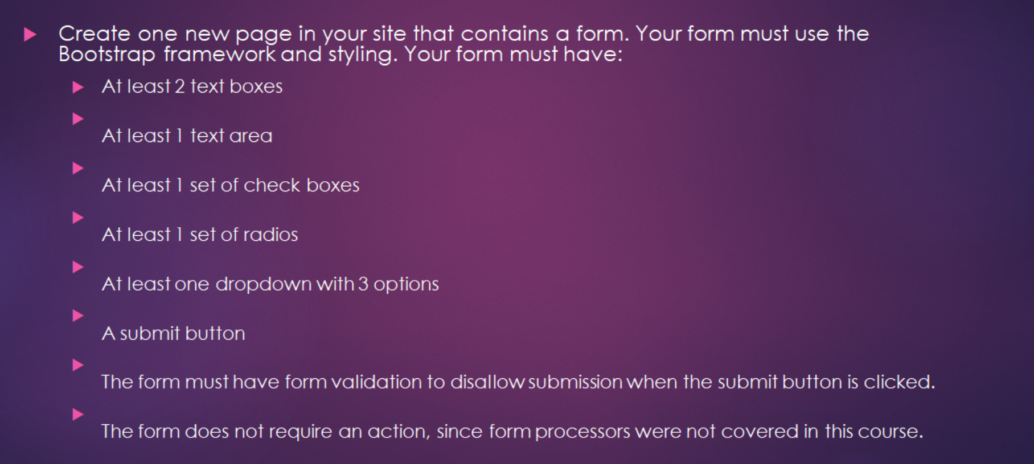

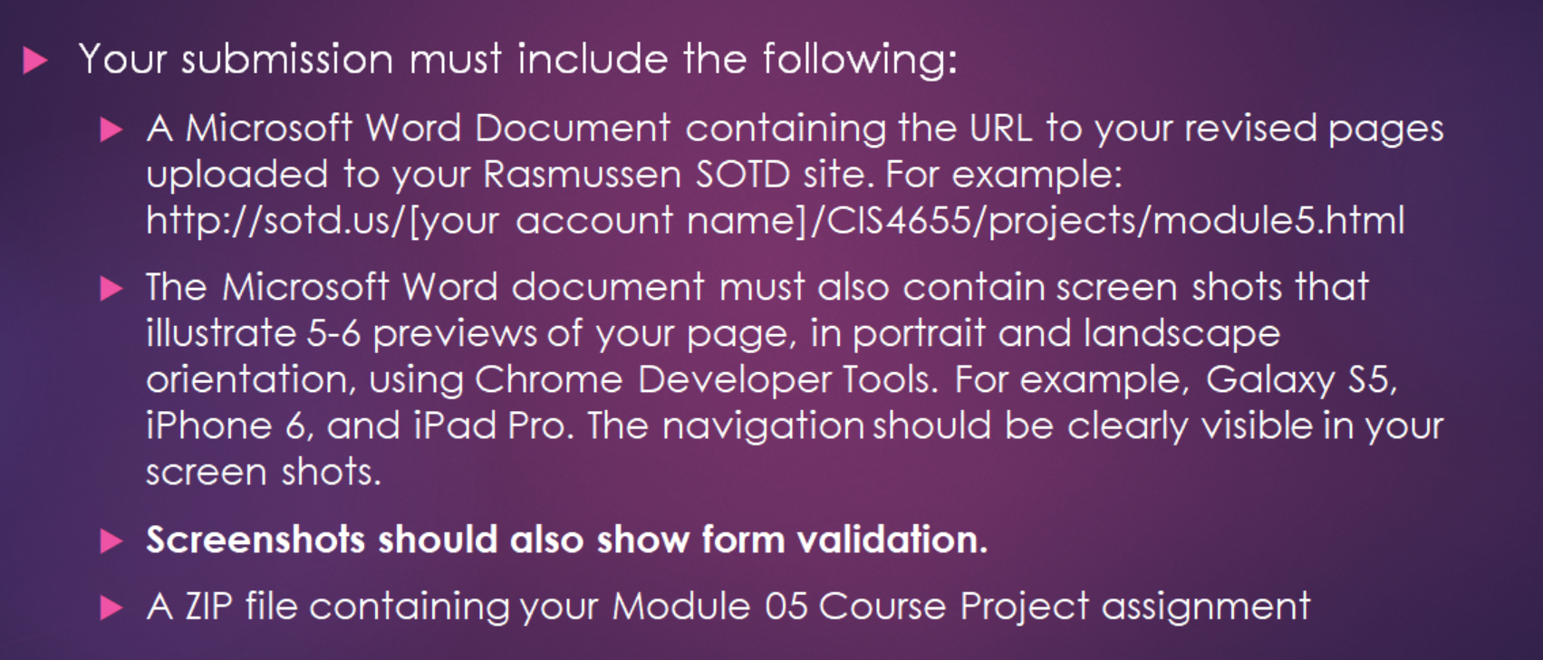

URL to uploaded SOTD site:   
<http://sotd.us/christinehodges/AdvWebDev/Module_05/project/form.html>

Github:

<https://github.com/fitactivemomgineer/AdvWebDev/blob/master/form.html>

Screenshots – 5-6 using Dev Tools

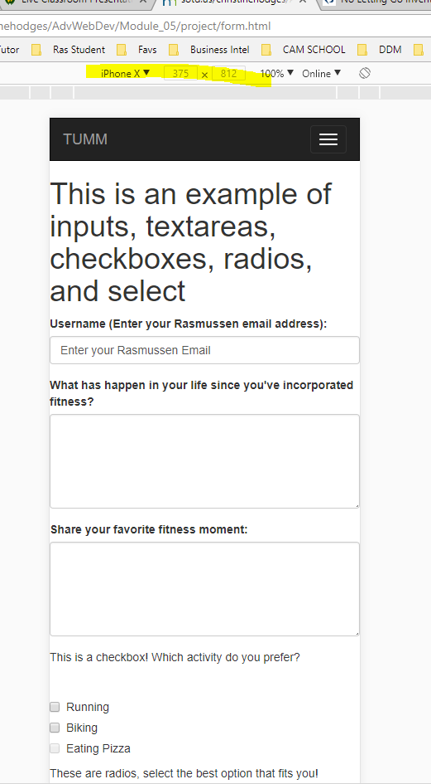

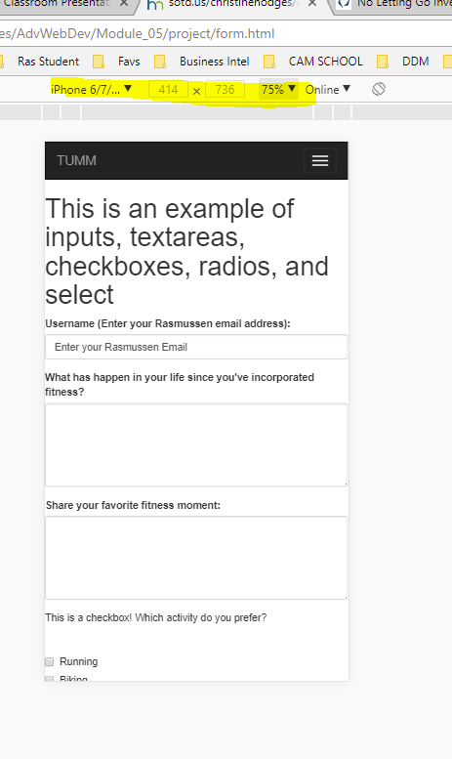 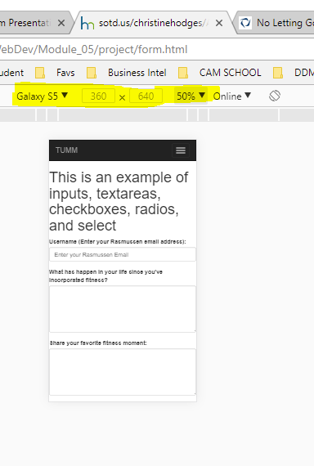 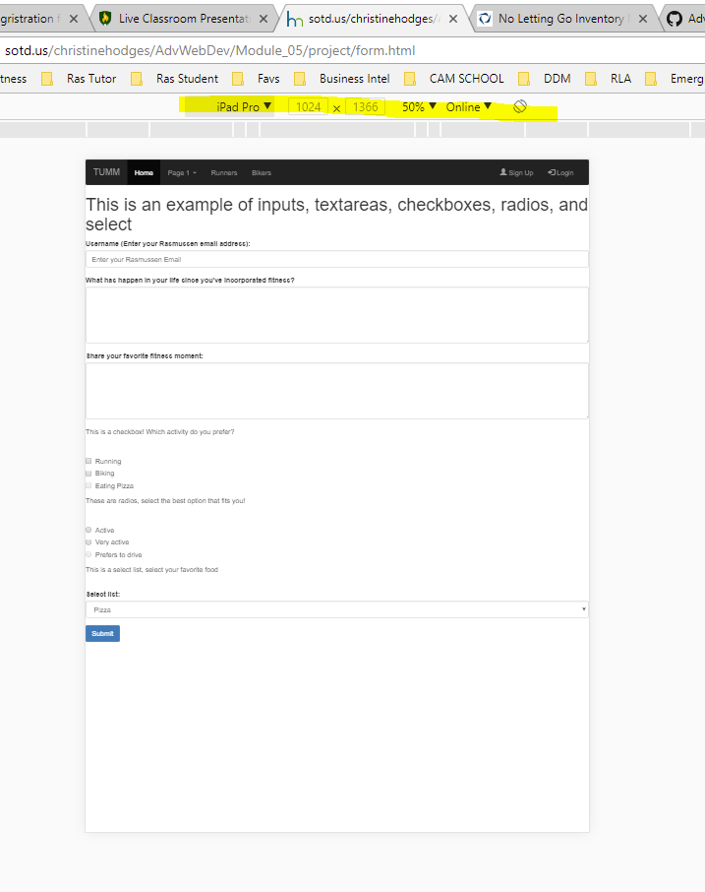 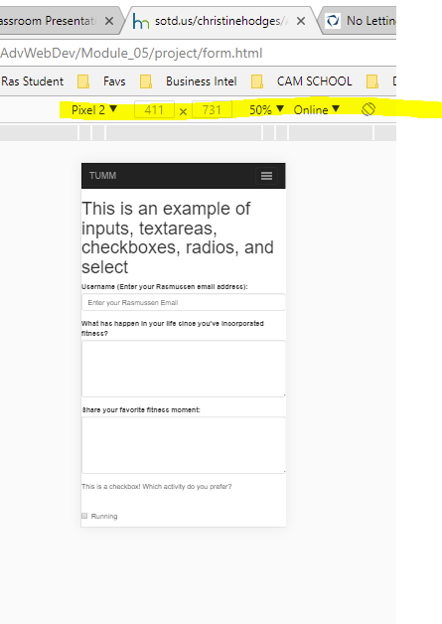 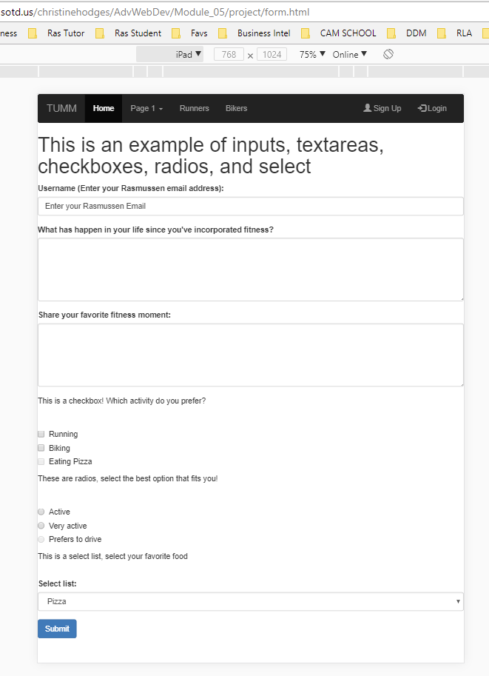

Screenshot showing form validation

